EXPERIMENT – 18
AIM :
To calculate the mean, median, and standard deviation of age and %fat, and to draw boxplots, a scatter plot, and a Q–Q plot for the given dataset.

ALGORITHM :
- Create two lists for age and fat%.
- Convert them into a Pandas DataFrame.
- Use Pandas functions to compute mean, median, std.
- Plot boxplots for age and fat%.
- Plot a scatter plot between age and fat%.
- Generate a Q–Q plot to check normal distribution.

CODE :
import pandas as pd
import matplotlib.pyplot as plt
import scipy.stats as stats

# Input data
age = [23, 23, 27, 27, 39, 41, 47, 49, 50, 52, 54, 54, 56, 57, 58, 58, 60, 61]
fat = [9.5, 26.5, 7.8, 17.8, 31.4, 25.9, 27.4, 27.2, 31.2,
34.6, 42.5, 28.8, 33.4, 30.2, 34.1, 32.9, 41.2, 35.7]

# Create DataFrame
df = pd.DataFrame({"Age": age, "%Fat": fat})

# Calculations
mean_age = df["Age"].mean()
median_age = df["Age"].median()
std_age = df["Age"].std()

mean_fat = df["%Fat"].mean()
median_fat = df["%Fat"].median()
std_fat = df["%Fat"].std()

print("Mean Age:", mean_age)
print("Median Age:", median_age)
print("Std Age:", std_age)

print("\nMean %Fat:", mean_fat)
print("Median %Fat:", median_fat)
print("Std %Fat:", std_fat)

# Boxplots
plt.figure(figsize=(10,4))
plt.subplot(1,2,1)
plt.boxplot(df["Age"])
plt.title("Boxplot of Age")

plt.subplot(1,2,2)
plt.boxplot(df["%Fat"])
plt.title("Boxplot of %Fat")
plt.show()

# Scatter Plot
plt.scatter(df["Age"], df["%Fat"])
plt.xlabel("Age")
plt.ylabel("%Fat")
plt.title("Scatter Plot: Age vs %Fat")
plt.show()

# Q-Q Plot
stats.probplot(df["Age"], dist="norm", plot=plt)
plt.title("Q-Q Plot for Age")
plt.show()

stats.probplot(df["%Fat"], dist="norm", plot=plt)
plt.title("Q-Q Plot for %Fat")
plt.show()

INPUT :
Age: 23, 23, 27, 27, 39, 41, 47, 49, 50, 52, 54, 54, 56, 57, 58, 58, 60, 61
%Fat: 9.5, 26.5, 7.8, 17.8, 31.4, 25.9, 27.4, 27.2, 31.2,
34.6, 42.5, 28.8, 33.4, 30.2, 34.1, 32.9, 41.2, 35.7

OUTPUT :
Mean Age: 45.833
Median Age: 48.0
Std Age: 13.07

Mean %Fat: 29.49
Median %Fat: 30.5
Std %Fat: 9.26
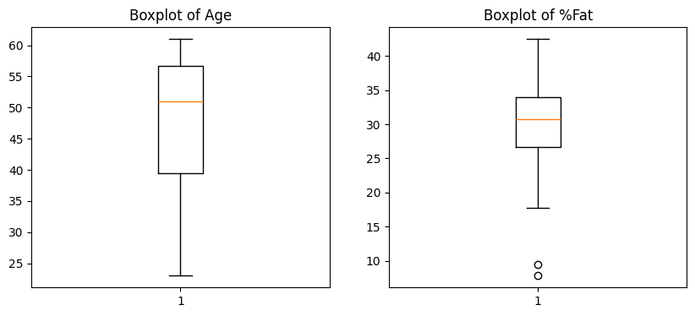
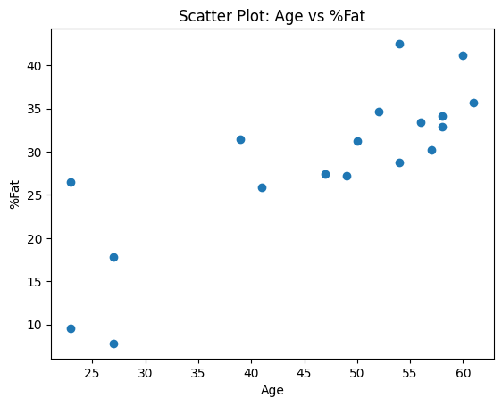
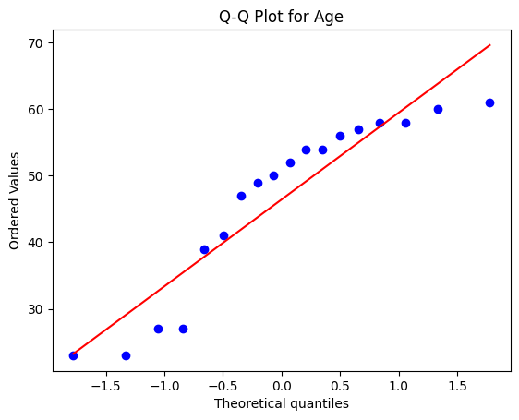
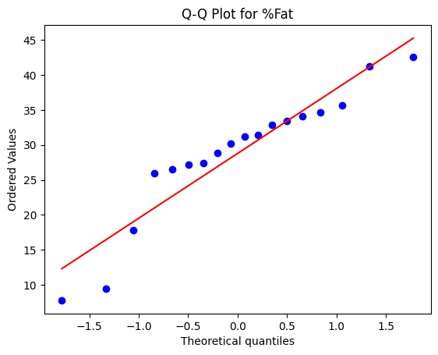

RESULT :
The analysis successfully calculated the mean, median, and standard deviation for both age and body fat %. It also generated boxplots, a scatter plot, and Q–Q plots, clearly showing the distribution and relationship between the two variables.

